***Project Report***

Report for project : ‘The Desired Café’

Report created: 12:10 am 23 April 2018

Report created by: Mir Rakibuzzaman

Report submitted to: MAZ3

Project group members & their contribution :

* Coding
  + - * Mir Rakibuzzaman
* Design & Debugging
  + - * Walid Al Habib
      * Hasibur Rahman
      * Sheikh Mohammad Abrar Jahin
* Idea Implementation
  + - * Mir Rakibuzzaman (NSU ID-1812596642)
      * Walid Al Habib (NSU ID-1812612642)
      * Hasibur Rahman (NSU ID-1812046642)
      * Sheikh Mohammad Abrar Jahin (NSU ID-1813302642)

**Initial Report :**

The program created for the project is called 'The Desired Cafe' . The is a restaurant order management program. Now we will be taking a look at it. Now at the start of the program we have 6 header files in total. Their uses will be discussed later on. They are standard input and output, console input output, standard library, string, windows and time header files.

Next there are the global variable declaration part. where 2 character variable , a ton of integer variables and a total of 15 strings.

Next comes the part where functions are declared. a total of 12 functions have been declared. Some of which are pretty self-explanatory while some of them are not. From the top they are called sum, order, payment, desire, more_desire, cash, credit, list, choice, menu1, menu2, splash_screen and Delay.

There is a structure called the customer structure. Which has been used to create a custom data type called cust. That will consist of the customers first name, last name, address, mobile no. and credit card no.

Then comes the main function we all have been waiting for. Here we have used system("color F1"); Which give our program a bright white background with rich blue text. Ideal for user readability. Then comes the splash screen function. Which shows the name of our restaurant in a cascading animation sequence. Then the variables for counting how many item ordered are set to 0 since the user has not made an order yet.

Then the welcoming consisting of our shop logo is printed to the console along with the menu. we used string calling to do that. After the entire menu is printed out the user is asked of a choice. Whether the user is ready to make an order as shown here. Now the user has two options either to cancel entering 0. Or making an order by entering 1. then the choice redirects to either exit (0); or to the order function. where we have used switch case and some counters to take the orders from users

In case if the user makes an error while making a choice we have used recursion. Where the program gives the user a message about the error that he has made. then the order function is called again.

After which the program executes the function more_desire() where the user is asked if he/she has the desire to order more. in that system("cls"); is used to clear the screen and he menu is shown again followed by the functions of desire() and more_desire(). After the order has been taken and the user has chosen no to the more desire dialogue. The function payment() is executed where the user is asked to choose between credit card payment and cash payment. and takes appropriate credentials using cash and credit functions. then the sum of the whole order is calculated. The list function is executed. where the user info is shown and his order details are shown as well. While the credit card info is hidden. Then after bidding farewell and thanking the user the program ends.

In the future we have planned to modify the program so that the order created by the user is saved in a file. And a manager program that uses the file to confirm orders and make preparations ASAP. Such that the program can be used as a real-world application. Certain modifications to the program can be used to mange bookings or other orders and micro-transactions.

The detailed code is attached to this report. And some working screenshots have also been added to this document below.

**Working screenshots:**

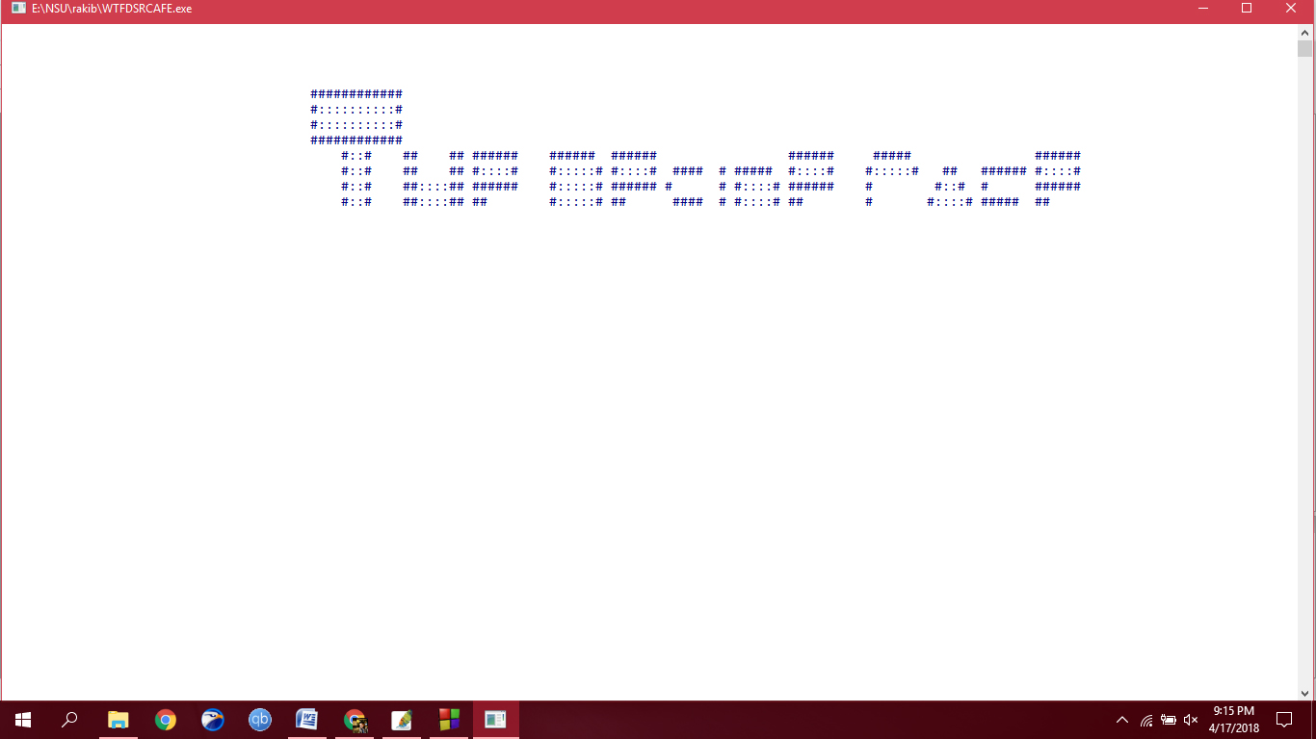

The Cascading animation.

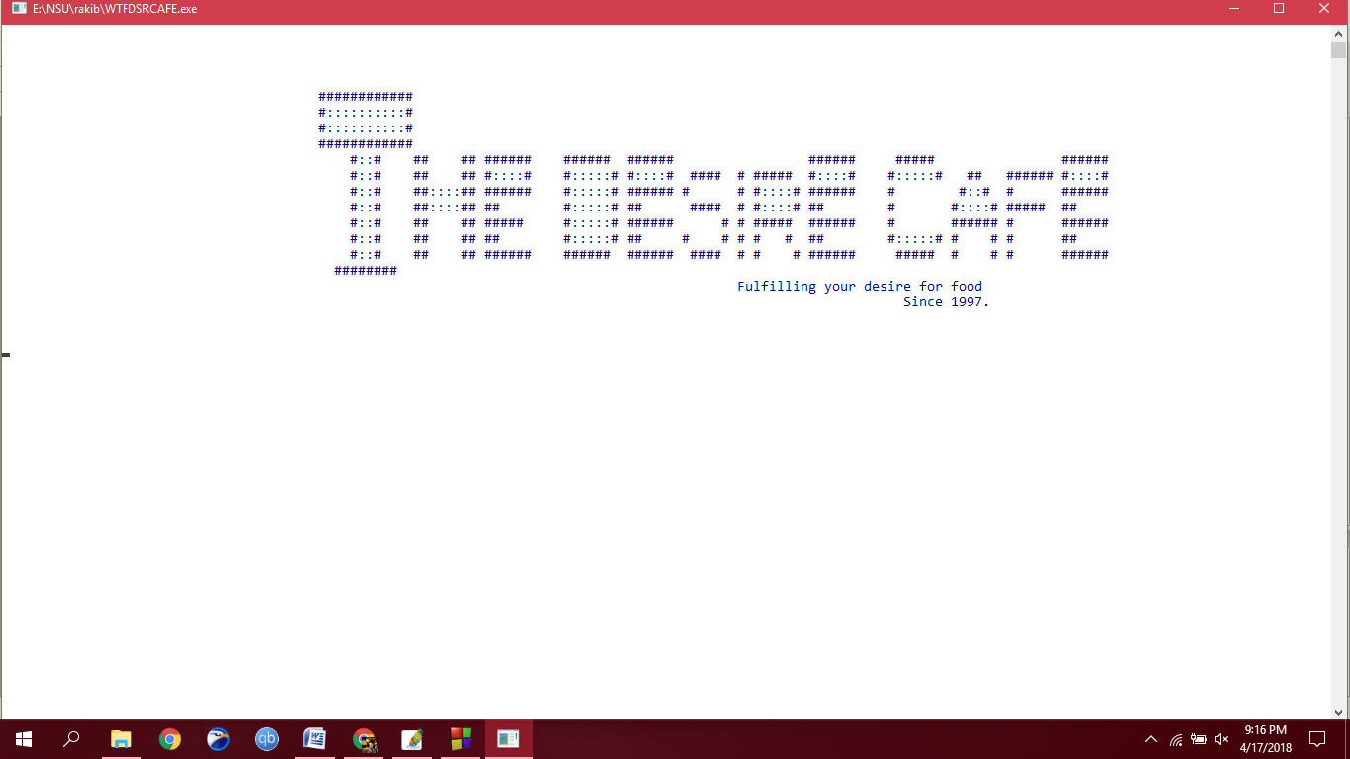

The delay between the menu shown and animation completed .

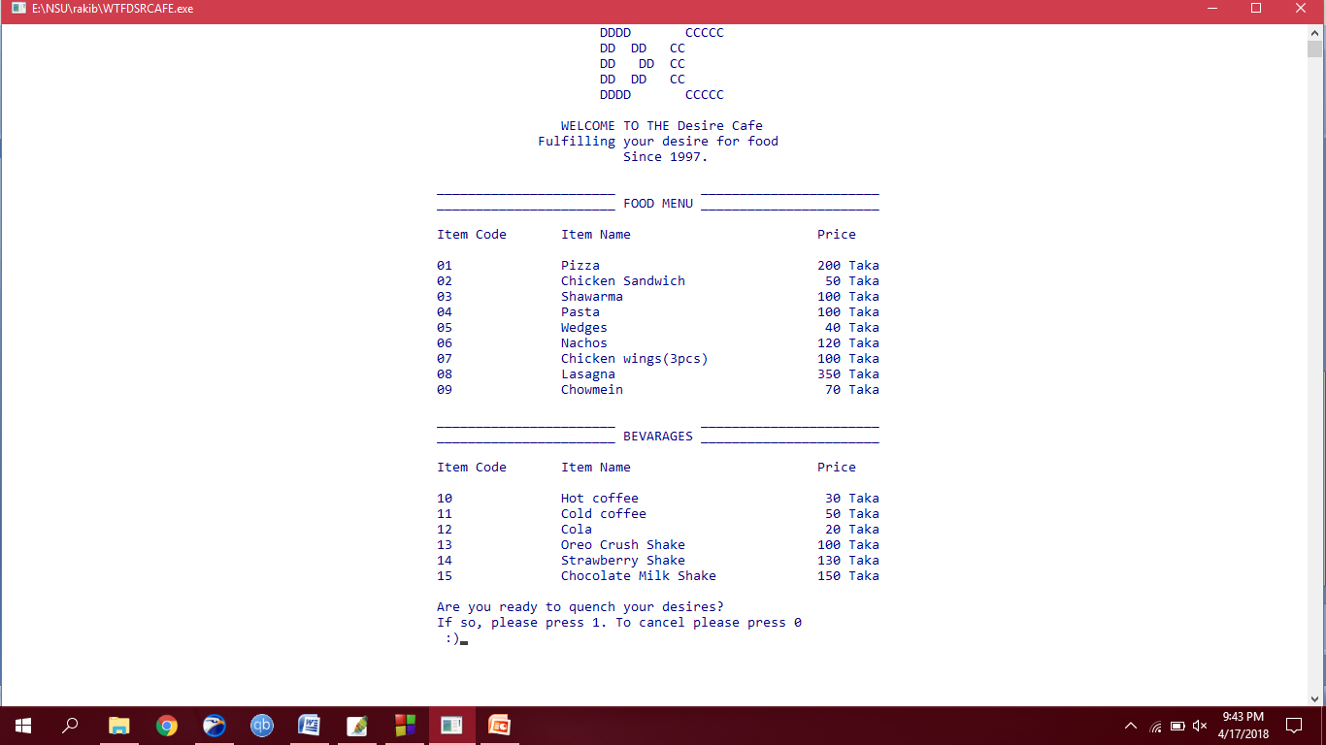The menu is shown after clearing the screen.

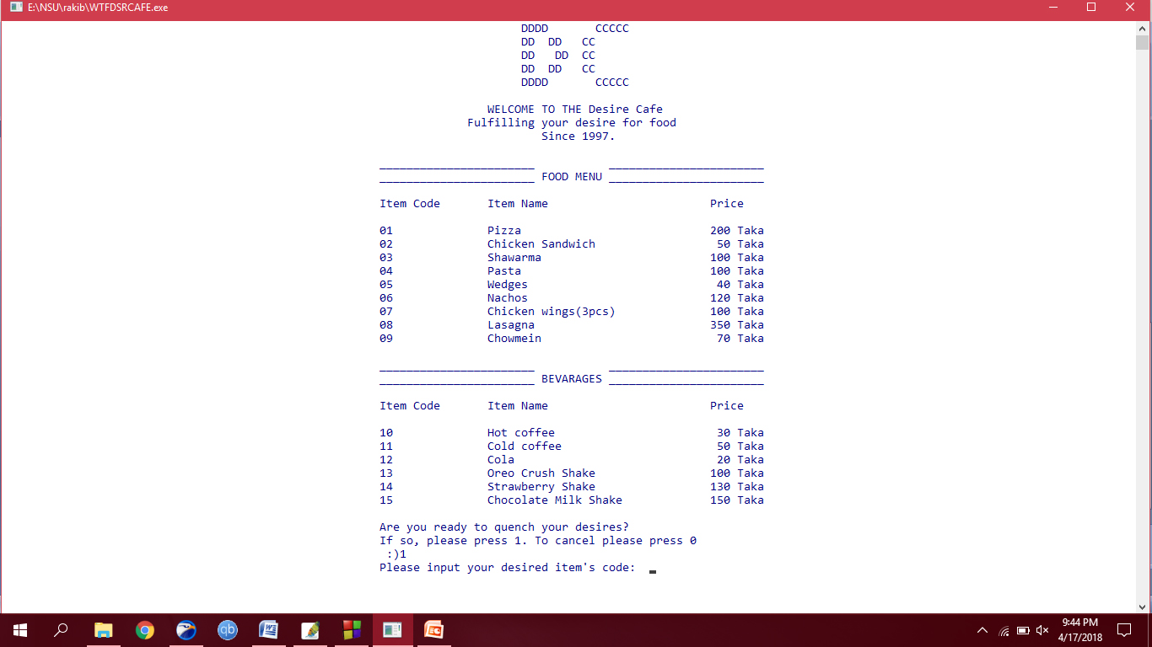

The user is again asked to input an item code of choice provided that he/she has chosen to quench his/her desires.

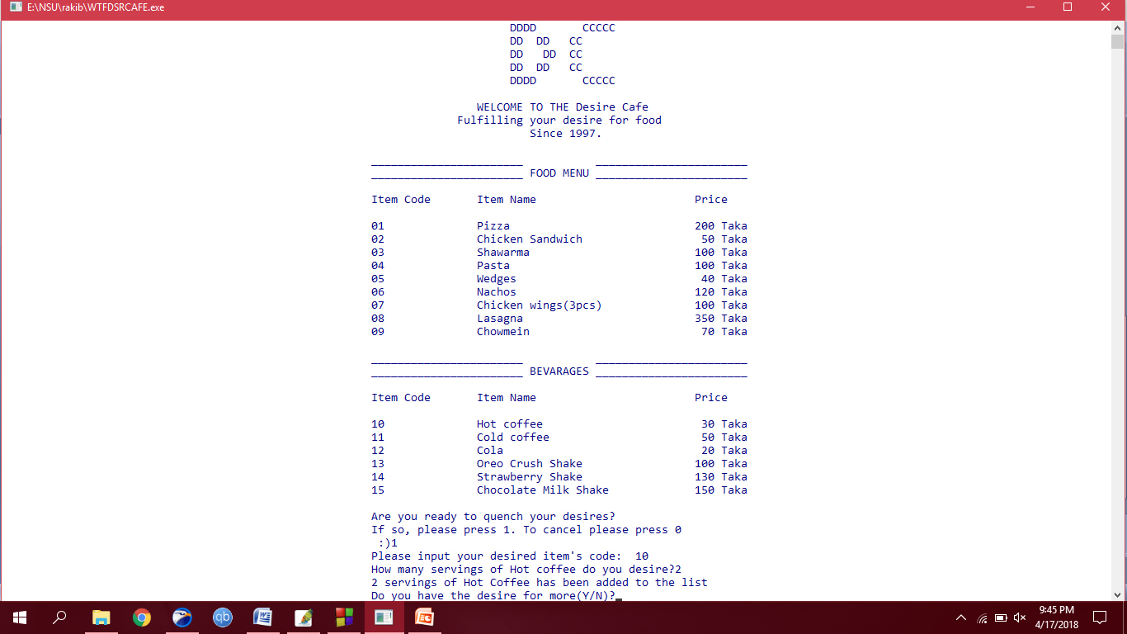

The user has input the item code ‘10’ for hot coffee. And required 2 servings of hot coffee. After which he/she is asked whether or not he/she has the desire for more. A simple Yes or No question.

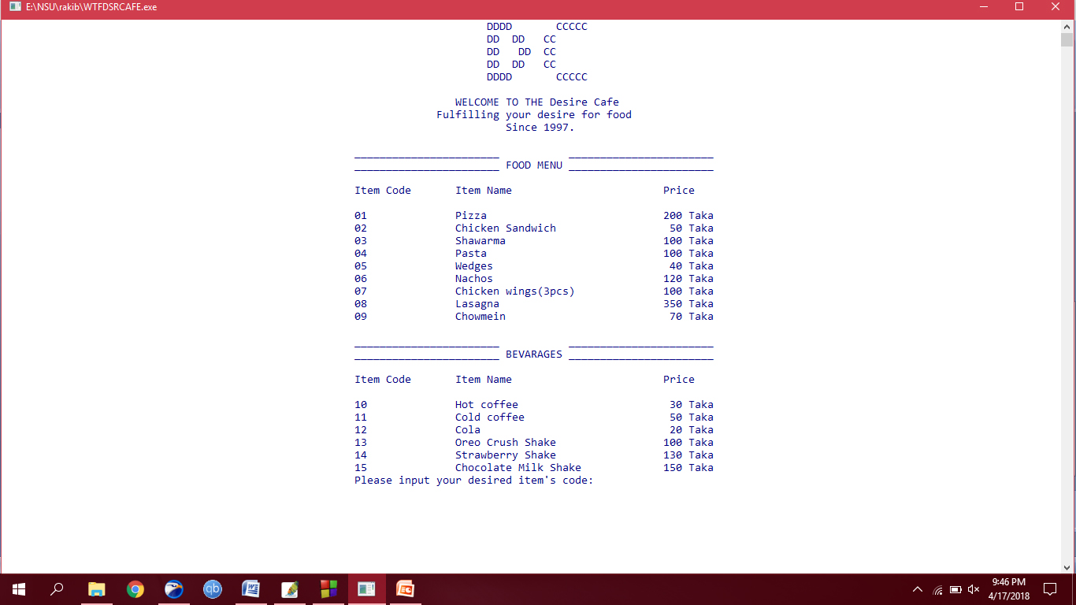

After selecting Yes the screen is cleared and the menu is re-written.

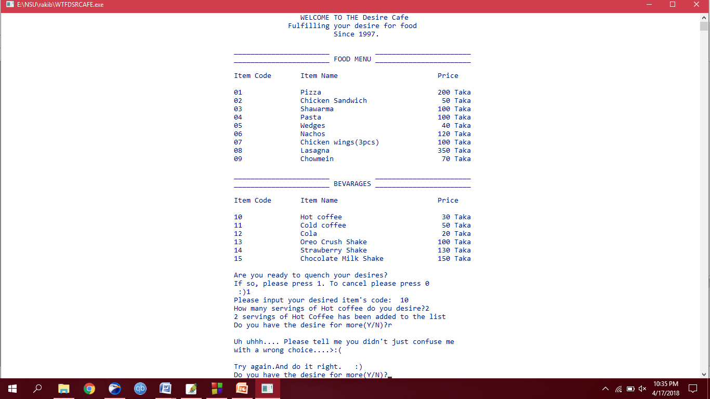

The functions are recurred and error handling is done.

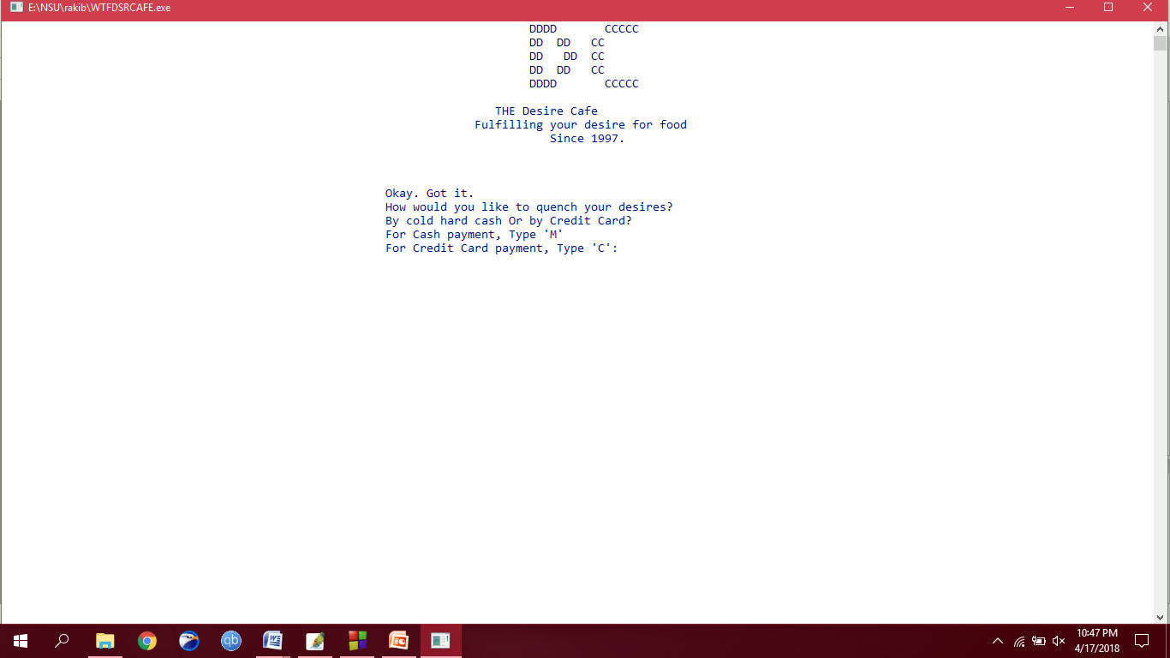

If Chosen no, the program asks for the users’ choice of payment in either cash or credit.

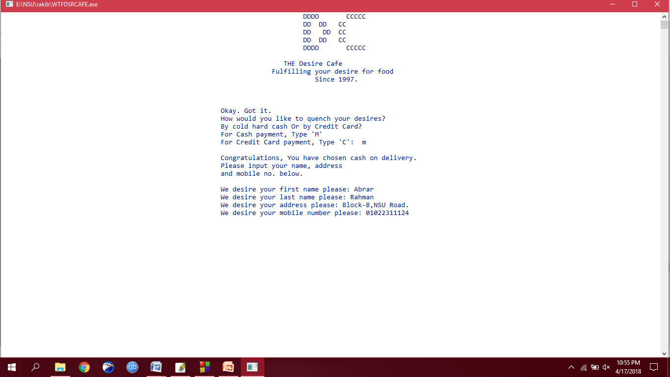

If the input ‘m’ the function ‘cash’ is executed. And the user is asked for his/her name, address and mobile number sequentially.

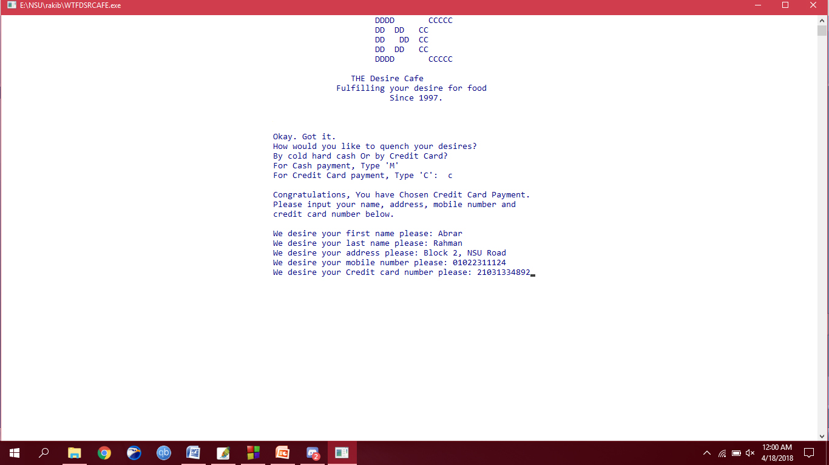

If the input ‘c’ the function ‘credit’ is executed. And the user is asked for his/her name, address, mobile number and credit card number sequentially.

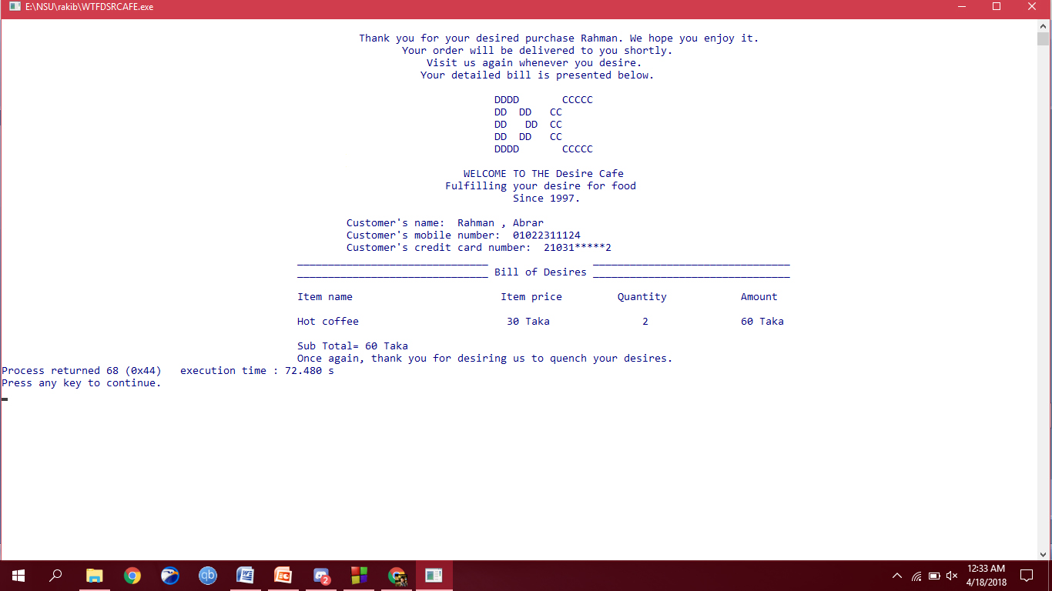

The list function is executed here. The details of purchase and the customer’s details are shown. Notice that extra sensitive information like the customer’s address isn’t shown. Or like the credit card number, which is partially shown.

**Detailed Code:**

#include<stdio.h>

#include<conio.h>

#include<stdlib.h>

#include<string.h>

#include<windows.h>

#include<time.h>

//*************************************************************************************

// Global Declaration

//****************e*********************************************************************

char ch='y',r;

int chc,sum_of_order,s;

int quantity1,quantity2,quantity3,quantity4,quantity5,quantity6,quantity7,quantity8,quantity9, o,i;

int quantity10,quantity11,quantity12,quantity13,quantity14,quantity15;

int pizza,chicken,shawarma,pasta,wedges,nachos,wings,lasagna,chowmein;

int qpizza,qchicken,qshawarma,qpasta,qwedges,qnachos,qwings,qlasagna,qchowmein;

int pizza1,chicken1,shawarma1,pasta1,wedges1,nachos1,wings1,lasagna1,chowmein1;

int hcoffee,ccoffee,cola,oreo,strawberry,chocomilk;

int qhcoffee,qccoffee,qcola,qoreo,qstrawberry,qchocomilk;

int hcoffee1,ccoffee1,cola1,oreo1,strawberry1,chocomilk1;

char s1[]="Pizza\t\t\t\t 200 Taka";

char s2[]="Chicken Sandwich\t\t 50 Taka";

char s3[]="Shawarma\t\t\t 100 Taka";

char s4[]="Pasta\t\t\t\t 100 Taka";

char s5[]="Wedges\t\t\t\t 40 Taka";

char s6[]="Nachos\t\t\t\t 120 Taka";

char s7[]="Chicken wings(3pcs)\t\t 100 Taka";

char s8[]="Lasagna\t\t\t\t 350 Taka";

char s9[]="Chowmein\t\t\t 70 Taka";

char b1[]="Hot coffee\t\t\t 30 Taka";

char b2[]="Cold coffee\t\t\t 50 Taka";

char b3[]="Cola\t\t\t\t 20 Taka";

char b4[]="Oreo Crush Shake\t\t 100 Taka";

char b5[]="Strawberry Shake\t\t 130 Taka";

char b6[]="Chocolate Milk Shake\t\t 150 Taka";

//*************************************************************************************

// FUNCTIONS

//*************************************************************************************

int sum();

void order();

void payment();

void desire();

void more_desire();

void cash();

void credit();

void list();

void menu1();

void menu2();

void splash_screen();

void delay(unsigned int mseconds);

//*************************************************************************************

// STRUCTURES USED IN PROJECT

//*************************************************************************************

struct cust

{

char fname[50];

char lname[50];

char add[100];

char mob[14];

char crno[16];

}q;

//*************************************************************************************

// MAIN FUNCTION

//*************************************************************************************

void main()

{ system("COLOR F1");

splash_screen();

pizza1=chicken1=shawarma1=pasta1=wedges1=nachos1=wings1=lasagna1=chowmein1=0;

hcoffee1=ccoffee1=cola1=oreo1=strawberry1=chocomilk1=0;

printf("\t\t\t\t\t\t\t\t\t DDDD CCCCC\n");

printf("\t\t\t\t\t\t\t\t\t DD DD CC\n");

printf("\t\t\t\t\t\t\t\t\t DD DD CC\n");

printf("\t\t\t\t\t\t\t\t\t DD DD CC\n");

printf("\t\t\t\t\t\t\t\t\t DDDD CCCCC\n\n");

printf("\t\t\t\t\t\t\t\t\tWELCOME TO THE Desire Cafe\n");

printf("\t\t\t\t\t\t\t\t Fulfilling your desire for food\n");

printf("\t\t\t\t\t\t\t\t\t\tSince 1997.\n\n");

printf("\t\t\t\t\t\t\t_______________________ _______________________\n");

printf("\t\t\t\t\t\t\t_______________________ FOOD MENU _______________________\n\n");

printf("\t\t\t\t\t\t\tItem Code\tItem Name\t\t\t\t Price\n\n");

printf("\t\t\t\t\t\t\t01\t\t");

for(i=0;s1[i];i++)

printf("%c",s1[i]);

printf("\n");

printf("\t\t\t\t\t\t\t02\t\t");

for(i=0;s2[i];i++)

printf("%c",s2[i]);

printf("\n");

printf("\t\t\t\t\t\t\t03\t\t");

for(i=0;s3[i];i++)

printf("%c",s3[i]);

printf("\n");

printf("\t\t\t\t\t\t\t04\t\t");

for(i=0;s4[i];i++)

printf("%c",s4[i]);

printf("\n");

printf("\t\t\t\t\t\t\t05\t\t");

for(i=0;s5[i];i++)

printf("%c",s5[i]);

printf("\n");

printf("\t\t\t\t\t\t\t06\t\t");

for(i=0;s6[i];i++)

printf("%c",s6[i]);

printf("\n");

printf("\t\t\t\t\t\t\t07\t\t");

for(i=0;s7[i];i++)

printf("%c",s7[i]);

printf("\n");

printf("\t\t\t\t\t\t\t08\t\t");

for(i=0;s8[i];i++)

printf("%c",s8[i]);

printf("\n");

printf("\t\t\t\t\t\t\t09\t\t");

for(i=0;s9[i];i++)

printf("%c",s9[i]);

printf("\n");

printf("\n");

printf("\t\t\t\t\t\t\t_______________________ _______________________\n");

printf("\t\t\t\t\t\t\t_______________________ BEVARAGES _______________________\n\n");

printf("\t\t\t\t\t\t\tItem Code\tItem Name\t\t\t\t Price\n\n");

printf("\t\t\t\t\t\t\t10\t\t");

for(i=0;b1[i];i++)

printf("%c",b1[i]);

printf("\n");

printf("\t\t\t\t\t\t\t11\t\t");

for(i=0;b2[i];i++)

printf("%c",b2[i]);

printf("\n");

printf("\t\t\t\t\t\t\t12\t\t");

for(i=0;b3[i];i++)

printf("%c",b3[i]);

printf("\n");

printf("\t\t\t\t\t\t\t13\t\t");

for(i=0;b4[i];i++)

printf("%c",b4[i]);

printf("\n");

printf("\t\t\t\t\t\t\t14\t\t");

for(i=0;b5[i];i++)

printf("%c",b5[i]);

printf("\n");

printf("\t\t\t\t\t\t\t15\t\t");

for(i=0;b6[i];i++)

printf("%c",b6[i]);

printf("\n");

printf("\n\t\t\t\t\t\t\tAre you ready to quench your desires?\n\t\t\t\t\t\t\tIf so, please press 1. To cancel please press 0\n\t\t\t\t\t\t\t :)");

desire();

sum_of_order=sum();

list();

}

//*************************************************************************************

// START OF FUNCTION DEFINITION

//*************************************************************************************

void order()

{

printf("\t\t\t\t\t\t\tPlease input your desired item's code: ");

scanf("%d",&o);

fflush(stdin);

switch(o)

{

case 1:

printf("\t\t\t\t\t\t\tHow many Pizzas do you desire?");

scanf("%d",&quantity1);

pizza=(200*quantity1)+pizza;

printf("\t\t\t\t\t\t\t%d Pizza(s) has been added to the list",quantity1);

pizza1=1;

qpizza=qpizza+quantity1;

break;

case 2:

printf("\t\t\t\t\t\t\tHow many Chicken Sandwiches do you desire?");

scanf("%d",&quantity2);

chicken=(50*quantity2)+chicken;

printf("\t\t\t\t\t\t\t%d Chicken Sandwiche(s) has been added to the list",quantity2);

chicken1=1;

qchicken=qchicken+quantity2;

break;

case 3:

printf("\t\t\t\t\t\t\tHow many Shawarmas do you desire?");

scanf("%d",&quantity3);

shawarma=(100*quantity3);

printf("\t\t\t\t\t\t\t%d Shawarma(s) has been added to the list",quantity3);

shawarma1=1;

qshawarma=qshawarma+quantity3;

break;

case 4:

printf("\t\t\t\t\t\t\tHow many servings of Pastas do you desire?");

scanf("%d",&quantity4);

pasta=(100*quantity4)+pasta;

printf("\t\t\t\t\t\t\t%d servings of Pastas has been added to the list",quantity4);

pasta1=1;

qpasta=qpasta+quantity4;

break;

case 5:

printf("\t\t\t\t\t\t\tHow many servings of Wedges do you desire?");

scanf("%d",&quantity5);

wedges=(40*quantity5)+wedges;

printf("\t\t\t\t\t\t\t%d servings Wedges has been added to the list",quantity5);

wedges1=1;

qwedges=qwedges+quantity5;

break;

case 6:

printf("\t\t\t\t\t\t\tHow many servings of Nachos do you desire?");

scanf("%d",&quantity6);

nachos=(120*quantity6)+nachos;

printf("\t\t\t\t\t\t\t%d servings of Nachos has been added to the list",quantity6);

nachos1=1;

qnachos=qnachos+quantity6;

break;

case 7:

printf("\t\t\t\t\t\t\tHow many servings of Chicken wings do you desire?");

scanf("%d",&quantity7);

wings=(100*quantity7)+wings;

printf("\t\t\t\t\t\t\t%d servings Chicken Wings has been added to the list",quantity7);

wings1=1;

qwings=qwings+quantity7;

break;

case 8:

printf("\t\t\t\t\t\t\tHow many servings of Lasagna do you desire?");

scanf("%d",&quantity8);

lasagna=(350*quantity8)+lasagna;

printf("\t\t\t\t\t\t\t%d servings of Lasagna has been added to the list",quantity8);

lasagna1=1;

qlasagna=qlasagna+quantity8;

break;

case 9:

printf("\t\t\t\t\t\t\tHow many servings of Chowmein do you desire?");

scanf("%d",&quantity9);

chowmein=(70*quantity9)+chowmein;

printf("\t\t\t\t\t\t%d servings of Chowmein has been added to the list",quantity9);

chowmein1=1;

qchowmein=qchowmein+quantity9;

break;

case 10:

printf("\t\t\t\t\t\t\tHow many servings of Hot coffee do you desire?");

scanf("%d",&quantity10);

hcoffee=(30*quantity10)+hcoffee;

printf("\t\t\t\t\t\t\t%d servings of Hot Coffee has been added to the list",quantity10);

hcoffee1=1;

qhcoffee=qhcoffee+quantity10;

break;

case 11:

printf("\t\t\t\t\t\t\tHow many servings of Cold coffee do you desire?");

scanf("%d",&quantity11);

ccoffee=(50*quantity11)+ccoffee;

printf("\t\t\t\t\t\t\t%d servings of Cold Coffee has been added to the list",quantity11);

ccoffee1=1;

qccoffee=qccoffee+quantity11;

break;

case 12:

printf("\t\t\t\t\t\t\tHow many servings of Cola do you desire?");

scanf("%d",&quantity12);

cola=(20*quantity12)+cola;

printf("\t\t\t\t\t\t\t%d Servings of Cola has been added to the list",quantity12);

cola1=1;

qcola=qcola+quantity12;

break;

case 13:

printf("\t\t\t\t\t\t\tHow many servings of Oreo Crush Shake do you desire?");

scanf("%d",&quantity13);

oreo=(100*quantity13)+oreo;

printf("\t\t\t\t\t\t\t%d servings of Oreo Crush Shake has been added to the list",quantity13);

oreo1=1;

qoreo=qoreo+quantity13;

break;

case 14:

printf("\t\t\t\t\t\t\tHow many servings of Strawberry Milk Shake do you desire?");

scanf("%d",&quantity14);

strawberry=(130*quantity14)+strawberry;

printf("\t\t\t\t\t\t\t%d servings of Strawberry Milk Shake has been added to the list",quantity14);

strawberry1=1;

qstrawberry=qstrawberry+quantity14;

break;

case 15:

printf("\t\t\t\t\t\t\tHow many servings of Chocolate Milk Shake do you desire?");

scanf("%d",&quantity15);

chocomilk=(150*quantity15)+chocomilk;

printf("\t\t\t\t\t\t\t%d servings of Chocolate Milk Shake has been added to the list",quantity15);

chocomilk1=1;

qchocomilk=qchocomilk+quantity15;

break;

default:

printf("\n\t\t\t\t\t\t\tUh uhhh.... Please tell me you didn't just confuse me\n\t\t\t\t\t\t\twith a wrong choice....>:(\n\n");

printf("\t\t\t\t\t\t\tTry again.And do it right. :)");

order();

}

}

void payment()

{ printf("\n\t\t\t\t\t\t\tOkay. Got it.\n");

printf("\t\t\t\t\t\t\tHow would you like to quench your desires?\n\t\t\t\t\t\t\tBy cold hard cash Or by Credit Card?\n");

printf("\t\t\t\t\t\t\tFor Cash payment, Type 'M'\n");

printf("\t\t\t\t\t\t\tFor Credit Card payment, Type 'C': ");

char r;

fflush(stdin);

scanf("%c",&r);

if(r=='m' || r=='M')

{

cash();

}

else if(r=='c' || r=='C')

{

credit();

}

else

{ printf("\n\t\t\t\t\t\t\tUh uhhh.... Please tell me you didn't just confuse me\n\t\t\t\t\t\t\twith a wrong choice....>:(\n\n");

printf("\t\t\t\t\t\t\tTry again.And do it right. :)\n");

payment();

}

}

void desire(int q)

{

scanf("%d",&chc);

fflush(stdin);

switch(chc)

{

case 1:

order();

more_desire();

break;

case 0:

exit(0);

default:

printf("\n\t\t\t\t\t\t\tUh uhhh.... Please tell me you didn't just confuse me\n\t\t\t\t\t\t\twith a wrong choice....>:(\n\n");

printf("\t\t\t\t\t\t\tTry again.And do it right. :)");

printf("\n\t\t\t\t\t\t\tIf you are ready to quench your desires, please press 1. To cancel please press 0\n\t\t\t\t\t\t\t :)");

desire(chc);

}

}

void more_desire()

{

printf("\n\t\t\t\t\t\t\tDo you have the desire for more(Y/N)?");

fflush(stdin);

scanf("%c", &ch);

if(ch=='y' || ch=='Y')

{

system("cls");

menu2();

order();

more_desire();

}

else if(ch=='n' || ch=='N')

{

system("cls");

menu1();

payment();

}

else

{

printf("\n\t\t\t\t\t\t\tUh uhhh.... Please tell me you didn't just confuse me\n\t\t\t\t\t\t\twith a wrong choice....>:(\n\n");

printf("\t\t\t\t\t\t\tTry again.And do it right. :)");

more_desire();

}

}

void cash()

{

printf("\n\t\t\t\t\t\t\tCongratulations, You have chosen cash on delivery.\n");

printf("\t\t\t\t\t\t\tPlease input your name, address\n\t\t\t\t\t\t\tand mobile no. below.\n");

printf("\n\t\t\t\t\t\t\tWe desire your first name please: ");

fflush(stdin);

scanf("%s",&q.fname);

fflush(stdin);

printf("\t\t\t\t\t\t\tWe desire your last name please: ");

scanf("%s",&q.lname);

fflush(stdin);

printf("\t\t\t\t\t\t\tWe desire your address please: ");

scanf("%s",&q.add);

fflush(stdin);

printf("\t\t\t\t\t\t\tWe desire your mobile number please: ");

scanf("%s",&q.mob);

}

void credit()

{

printf("\n\t\t\t\t\t\t\tCongratulations, You have Chosen Credit Card Payment.\n");

printf("\t\t\t\t\t\t\tPlease input your name, address, mobile number and \n\t\t\t\t\t\t\tcredit card number below.\n");

printf("\n\t\t\t\t\t\t\tWe desire your first name please: ");

fflush(stdin);

scanf("%s",&q.fname);

fflush(stdin);

printf("\t\t\t\t\t\t\tWe desire your last name please: ");

scanf("%s",&q.lname);

fflush(stdin);

printf("\t\t\t\t\t\t\tWe desire your address please: ");

scanf("%s",&q.add);

fflush(stdin);

printf("\t\t\t\t\t\t\tWe desire your mobile number please: ");

scanf("%s",&q.mob);

fflush(stdin);

printf("\t\t\t\t\t\t\tWe desire your Credit card number please: ");

scanf("%s",&q.crno);

}

int sum()

{

s=pizza+chicken+shawarma+pasta+wedges+nachos+wings+lasagna+chowmein+hcoffee+ccoffee+cola+oreo+strawberry+chocomilk;

return s;

}

void list()

{ system("cls");

printf("\n\t\t\t\t\t\t\t Thank you for your desired purchase %s. We hope you enjoy it.\n\t\t\t\t\t\t\t\t Your order will be delivered to you shortly.",q.lname);

printf("\n\t\t\t\t\t\t\t\t Visit us again whenever you desire.\n");

printf("\t\t\t\t\t\t\t\t Your detailed bill is presented below.\n\n");

printf("\t\t\t\t\t\t\t\t\t DDDD CCCCC\n");

printf("\t\t\t\t\t\t\t\t\t DD DD CC\n");

printf("\t\t\t\t\t\t\t\t\t DD DD CC\n");

printf("\t\t\t\t\t\t\t\t\t DD DD CC\n");

printf("\t\t\t\t\t\t\t\t\t DDDD CCCCC\n\n");

printf("\t\t\t\t\t\t\t\t\t WELCOME TO THE Desire Cafe\n");

printf("\t\t\t\t\t\t\t\t Fulfilling your desire for food\n");

printf("\t\t\t\t\t\t\t\t\t\t Since 1997.\n\n");

printf("\t\t\t\t\t\t\tCustomer's name: %s , %s\n",q.lname,q.fname);

printf("\t\t\t\t\t\t\tCustomer's mobile number: %s\n",q.mob);

printf("\t\t\t\t\t\t\tCustomer's credit card number: %s\b\b\b\b\b\b*****\n",q.crno);

printf("\t\t\t\t\t\t_______________________________ ________________________________\n");

printf("\t\t\t\t\t\t_______________________________ Bill of Desires ________________________________\n\n");

printf("\t\t\t\t\t\tItem name\t\t\t Item price\t\tQuantity\t\tAmount\n\n");

while(pizza1==1)

{

printf("\t\t\t\t\t\t");

printf("%s",s1);

printf("\t\t%d\t\t%d Taka",qpizza,pizza);

printf("\n");

break;

}

while(chicken1==1)

{

printf("\t\t\t\t\t\t");

printf("%s",s2);

printf("\t\t%d\t\t%d Taka",qchicken,chicken);

printf("\n");

break;

}

while(shawarma1==1)

{

printf("\t\t\t\t\t\t");

printf("%s",s3);

printf("\t\t%d\t\t%d Taka",qshawarma,shawarma);

printf("\n");

break;

}

while(pasta1==1)

{

printf("\t\t\t\t\t\t");

printf("%s",s4);

printf("\t\t%d\t\t%d Taka",qpasta,pasta);

printf("\n");

break;

}

while(wedges1==1)

{

printf("\t\t\t\t\t\t");

printf("%s",s5);

printf("\t\t%d\t\t%d Taka",qwedges,wedges);

printf("\n");

break;

}

while(nachos1==1)

{

printf("\t\t\t\t\t\t");

printf("%s",s6);

printf("\t\t%d\t\t%d Taka",qnachos,nachos);

printf("\n");

break;

}

while(wings1==1)

{

printf("\t\t\t\t\t\t");

printf("%s",s7);

printf("\t\t%d\t\t%d Taka",qwings,wings);

printf("\n");

break;

}

while(lasagna1==1)

{

printf("\t\t\t\t\t\t");

printf("%s",s8);

printf("\t\t%d\t\t%d Taka",qlasagna,lasagna);

printf("\n");

break;

}

while(chowmein1==1)

{

printf("\t\t\t\t\t\t");

printf("%s",s9);

printf("\t\t%d\t\t%d Taka",qchowmein,chowmein);

printf("\n");

break;

}

while(hcoffee1==1)

{

printf("\t\t\t\t\t\t");

printf("%s",b1);

printf("\t\t%d\t\t%d Taka",qhcoffee,hcoffee);

printf("\n");

break;

}

while(ccoffee1==1)

{

printf("\t\t\t\t\t\t");

printf("%s",b2);

printf("\t\t%d\t\t%d Taka",qccoffee,ccoffee);

printf("\n");

break;

}

while(cola1==1)

{

printf("\t\t\t\t\t\t");

printf("%s",b3);

printf("\t\t%d\t\t%d Taka",qcola,cola);

printf("\n");

break;

}

while(oreo1==1)

{

printf("\t\t\t\t\t\t");

printf("%s",b4);

printf("\t\t%d\t\t%d Taka",qoreo,oreo);

printf("\n");

break;

}

while(strawberry1==1)

{

printf("\t\t\t\t\t\t");

printf("%s",b5);

printf("\t\t%d\t\t%d Taka",qstrawberry,strawberry);

printf("\n");

break;

}

while(chocomilk1==1)

{

printf("\t\t\t\t\t\t");

printf("%s",b6);

printf("\t\t%d\t\t%d Taka",qchocomilk,chocomilk);

printf("\n");

break;

}

printf("\n\t\t\t\t\t\tSub Total= %d Taka",s);

printf("\n\t\t\t\t\t\tOnce again, thank you for desiring us to quench your desires.");

}

void menu1()

{

printf("\t\t\t\t\t\t\t\t\t DDDD CCCCC\n");

printf("\t\t\t\t\t\t\t\t\t DD DD CC\n");

printf("\t\t\t\t\t\t\t\t\t DD DD CC\n");

printf("\t\t\t\t\t\t\t\t\t DD DD CC\n");

printf("\t\t\t\t\t\t\t\t\t DDDD CCCCC\n\n");

printf("\t\t\t\t\t\t\t\t\tTHE Desire Cafe\n");

printf("\t\t\t\t\t\t\t\t Fulfilling your desire for food\n");

printf("\t\t\t\t\t\t\t\t\t\tSince 1997.\n\n\n");

}

void menu2()

{

printf("\t\t\t\t\t\t\t\t\t DDDD CCCCC\n");

printf("\t\t\t\t\t\t\t\t\t DD DD CC\n");

printf("\t\t\t\t\t\t\t\t\t DD DD CC\n");

printf("\t\t\t\t\t\t\t\t\t DD DD CC\n");

printf("\t\t\t\t\t\t\t\t\t DDDD CCCCC\n\n");

printf("\t\t\t\t\t\t\t\t\tWELCOME TO THE Desire Cafe\n");

printf("\t\t\t\t\t\t\t\t Fulfilling your desire for food\n");

printf("\t\t\t\t\t\t\t\t\t\tSince 1997.\n\n");

printf("\t\t\t\t\t\t\t_______________________ _______________________\n");

printf("\t\t\t\t\t\t\t_______________________ FOOD MENU _______________________\n\n");

printf("\t\t\t\t\t\t\tItem Code\tItem Name\t\t\t\t Price\n\n");

printf("\t\t\t\t\t\t\t01\t\t");

for(i=0;s1[i];i++)

{

printf("%c",s1[i]);

}

printf("\n");

printf("\t\t\t\t\t\t\t02\t\t");

for(i=0;s2[i];i++)

printf("%c",s2[i]);

printf("\n");

printf("\t\t\t\t\t\t\t03\t\t");

for(i=0;s3[i];i++)

printf("%c",s3[i]);

printf("\n");

printf("\t\t\t\t\t\t\t04\t\t");

for(i=0;s4[i];i++)

printf("%c",s4[i]);

printf("\n");

printf("\t\t\t\t\t\t\t05\t\t");

for(i=0;s5[i];i++)

printf("%c",s5[i]);

printf("\n");

printf("\t\t\t\t\t\t\t06\t\t");

for(i=0;s6[i];i++)

printf("%c",s6[i]);

printf("\n");

printf("\t\t\t\t\t\t\t07\t\t");

for(i=0;s7[i];i++)

printf("%c",s7[i]);

printf("\n");

printf("\t\t\t\t\t\t\t08\t\t");

for(i=0;s8[i];i++)

printf("%c",s8[i]);

printf("\n");

printf("\t\t\t\t\t\t\t09\t\t");

for(i=0;s9[i];i++)

printf("%c",s9[i]);

printf("\n");

printf("\n");

printf("\t\t\t\t\t\t\t_______________________ _______________________\n");

printf("\t\t\t\t\t\t\t_______________________ BEVARAGES _______________________\n\n");

printf("\t\t\t\t\t\t\tItem Code\tItem Name\t\t\t\t Price\n\n");

printf("\t\t\t\t\t\t\t10\t\t");

for(i=0;b1[i];i++)

printf("%c",b1[i]);

printf("\n");

printf("\t\t\t\t\t\t\t11\t\t");

for(i=0;b2[i];i++)

printf("%c",b2[i]);

printf("\n");

printf("\t\t\t\t\t\t\t12\t\t");

for(i=0;b3[i];i++)

printf("%c",b3[i]);

printf("\n");

printf("\t\t\t\t\t\t\t13\t\t");

for(i=0;b4[i];i++)

printf("%c",b4[i]);

printf("\n");

printf("\t\t\t\t\t\t\t14\t\t");

for(i=0;b5[i];i++)

printf("%c",b5[i]);

printf("\n");

printf("\t\t\t\t\t\t\t15\t\t");

for(i=0;b6[i];i++)

printf("%c",b6[i]);

printf("\n");

}

void splash_screen()

{

printf("\n\n\n\n");

printf("\t\t\t\t\t############ \n");

delay(500);

printf("\t\t\t\t\t#::::::::::# \n");

delay(500);

printf("\t\t\t\t\t#::::::::::# \n");

delay(500);

printf("\t\t\t\t\t############ \n");

delay(500);

printf("\t\t\t\t\t #::# ## ## ###### ###### ###### ###### ##### ######\n");

delay(500);

printf("\t\t\t\t\t #::# ## ## #::::# #:::::# #::::# #### # ##### #::::# #:::::# ## ###### #::::#\n");

delay(500);

printf("\t\t\t\t\t #::# ##::::## ###### #:::::# ###### # # #::::# ###### # #::# # ######\n");

delay(500);

printf("\t\t\t\t\t #::# ##::::## ## #:::::# ## #### # #::::# ## # #::::# ##### ## \n");

delay(500);

printf("\t\t\t\t\t #::# ## ## ##### #:::::# ###### # # ##### ###### # ###### # ######\n");

delay(500);

printf("\t\t\t\t\t #::# ## ## ## #:::::# ## # # # # # ## #:::::# # # # ## \n");

delay(500);

printf("\t\t\t\t\t #::# ## ## ###### ###### ###### #### # # # ###### ##### # # # ######\n");

delay(500);

printf("\t\t\t\t\t ######## \n");

delay(500);

printf("\t\t\t\t\t\t\t\t\t\t\t Fulfilling your desire for food\n");

delay(500);

printf("\t\t\t\t\t\t\t\t\t\t\t\t\t\t\t Since 1997.\n\n\n");

delay(4000);

system("cls");

}

void delay(unsigned int mseconds)

{

clock_t goal = mseconds + clock();

while (goal > clock());

}